**Renaissance – Voyages of Discovery - Geography**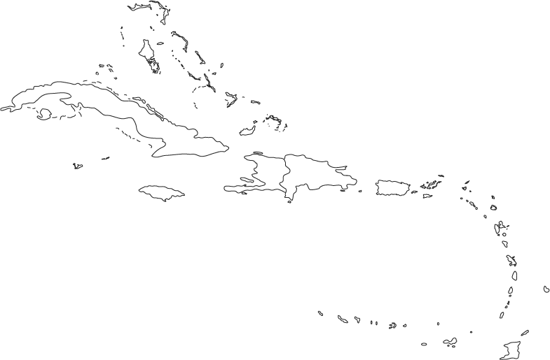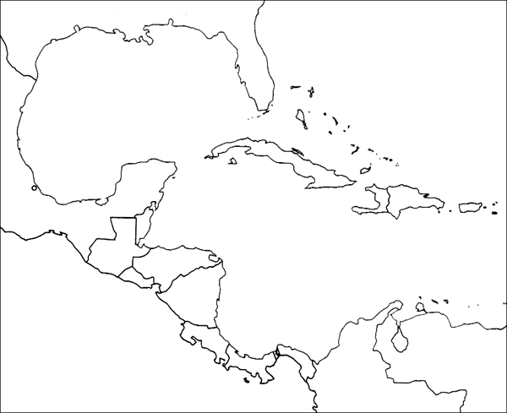

Columbus left Cadiz on 24 September 1493 to find new territories, with 17 ships carrying supplies, and about 1,200 men to colonize the region. The colonists included priests, farmers, and soldiers. This was part of a new policy — not just "colonies of exploitation", but "colonies of settlement" and conversion of the natives to Christianity

Voyage Number 2

Dates __________

Places visited

1.

2.

3.

4.

5.

6.

7.