**Renaissance – Voyages of Discovery - Geography**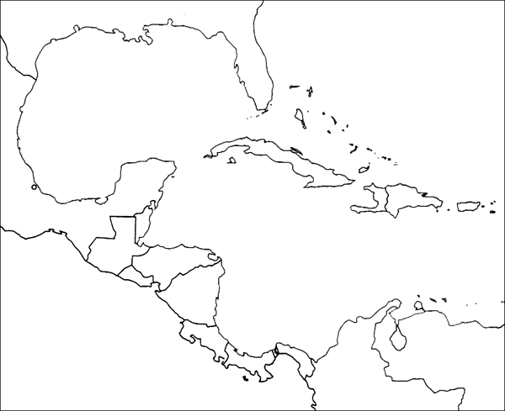

"Many of the men I have seen have scars on their bodies, and when I made signs to them to find out how this happened, they indicated that people from other nearby islands come to San Salvador to capture them; they defend themselves the best they can. I believe that people from the mainland come here to take them as slaves. They ought to make good and skilled servants, for they repeat very quickly whatever we say to them. I think they can very easily be made Christians, for they seem to have no religion.

Voyage Number 1

Dates __________

Places visited

1.

2.

3.

4.