Grade 8 Geography – Voluntourism
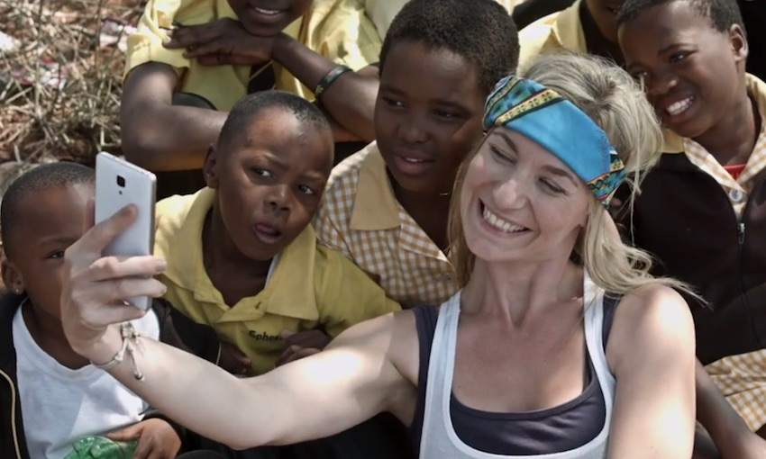
Find a definition of the term ‘voluntourism’. Imagine that you had to explain this to a younger person in primary school. How would you do this? Write our your simplified definition below.

Try to think of three positive things that voluntourism can make happen. State each factor below with a short sentence in the right hand column to explain why.

Try to think of one reason and then explain it.

Why so many young people choose to take part in voluntourism projects nowadays.

Watch the first video on geographypods – Who wants to be a volunteer?

Take some notes on the content of the video below. Then try to write a short sentence explaining the meaning of the video.

Watch the second video on geographypods – Let’s Save Africa – Gone Wrong!

Take some notes on the content of the video below. Then try to write a short sentence explaining the meaning of the video.

Conduct some research onto a very well known company called ‘Projects Abroad’. Spend some time looking through their website - https://www.projects-abroad.org/about-us/ - and find a project you that really appeals to you in the space below.

Click on the ‘Projects’ tab at the top of the page and then choose from the ‘Volunteer Abroad’ menu.

Type of trip (category from Volunteer Abroad tab)
Place
Brief explanation of activities that would be undertaken on this trip.
Cost

Watch this video about a Nepalese voluntourism organisation that was not all it seemed to be. In the space below, write about how they tricked people into giving money to this ‘good cause’.

