IGCSE Geography – Tracking Hurricane Matthew

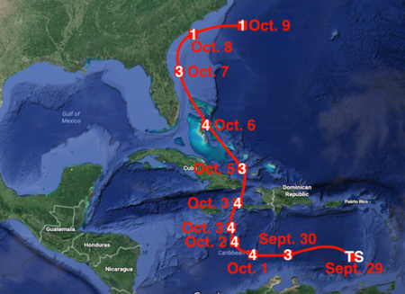
Use the questions on geographypods to make some rough notes around the visual below. This is an example of the sort of question you could be asked to complete on your Paper 2 skills exam.

