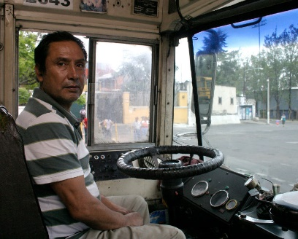**Year 8 - Thinking About Sinkholes**

Scenario 1 - A driver of a bus. Just leaving the large white building on the top right of the photo. The rain is beating down and your windscreen wipers are on full speed as you reach the cross roads in front and turn left onto 6A Calle ……

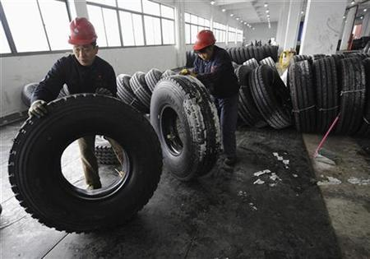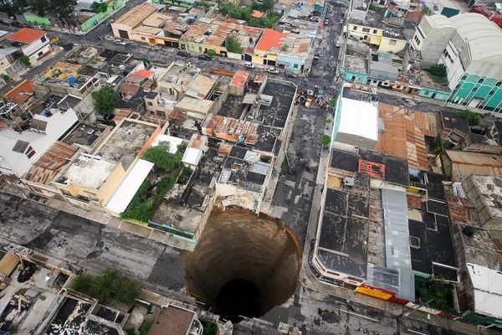

Scenario 2- A worker in the tyre factory on the cross roads. You are just coming towards the end of the morning shift and have been moving and loading tyres onto a delivery lorry stationed in front of the factory…….