The Balkans Route – Intervening Obstacles
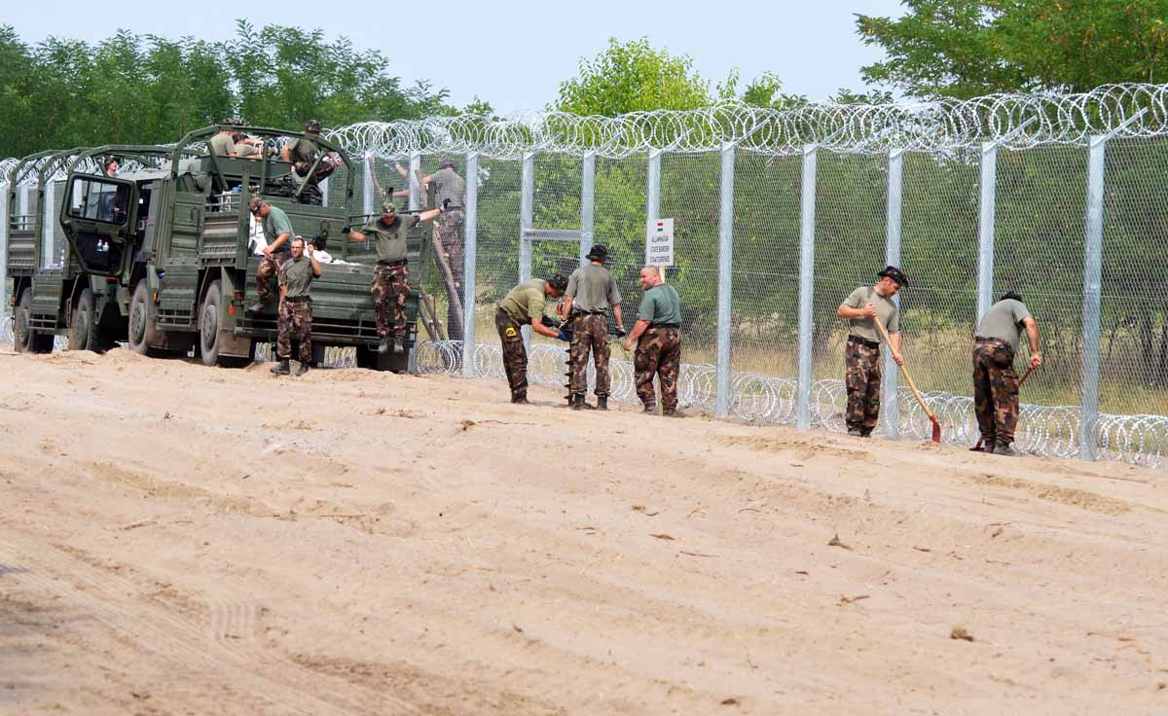
Watch each of the six videos and make notes on the intervening obstacles in the migrant’s plight to cross borders and to gain asylum.

Video 1 – Migrants in Lesbos (voyage from Turkey and journey across the island)

Video 2– Migrants in Macedonia

Video 3 – Migrants in Serbia
Video 4 – Migrants in Hungary

Video 5 – Migrants in Austria (explain what happened to the migrants in the lorry and conduct some further research to find out what the authorities have found out so far)

Video 6 – Migrants in Germany. Make notes on the application process in place as well as projected numbers of migrants seeking asylum in 2015.

One Final Hurdle – Crossing to the UK

Video 7 – France to UK – Life in the Jungle.

