G6 Geography – The 'Road' & Going Overseas!
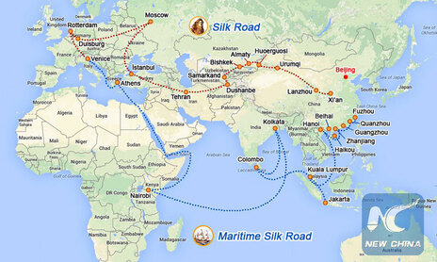
The maps above shows the Belt & Road Initiative. Look carefully at the ‘Maritime Silk Road’ route. In the space beneath, describe this route starting in China and ending in Italy. You should name one place in each country as well as the name of oceans / seas crossed. You should also use compass directions.
The Maritime Silk Road sets out from Fuzou on the east coast of China. From there, it heads south west along the coastline of China through another four ports before turning north west and arriving in Vietnam and the port city of H_____

Carry out some research on Vasco da Gama. Write a few sentences about him (including where he came from and what he was famous for) in the space below.

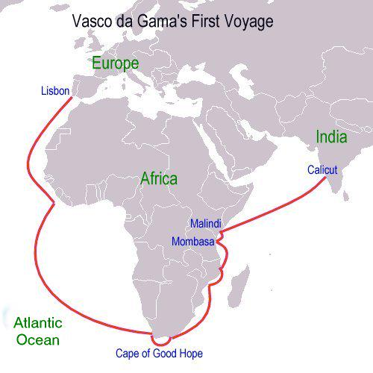

Above, you will see a map of da Gama’s fist voyage. Describe the route from Portugal to India. Make sure you include compass directions and name any countries that he stopped in.

Which engineering masterpiece (started in 19BC!) has changed the route from having to sail around the southern Cape of Africa to sailing straight from the Indian Ocean into the Mediterranean sea?

Using this video, (up to 6:20), carry out further research into this construction project and include some key dates, facts and figures in the space below.

A lot has changed since those original journeys made between Asia and Europe. As you have seen, the route has been shortened and technology has also been used to increase the amount of trade possible between different parts of the world.

About 95% of manufactured goods are transported from where they are made where you buy them. There's a good chance most of what you are wearing today came on a ship! Flying is much quicker but costs a lot and nowadays, container ships are huge and can carry huge volumes leading to a decrease in overall cost of transport (economies of scale).

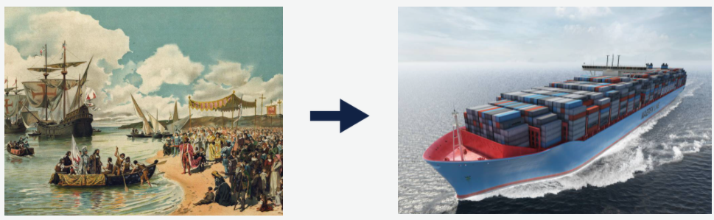

Using the embedded video on geographypods, find out about Malcom McLean. Some call him the modern godfather of globalization. Create a fact sheet on the next page about him and his inventions.

Malcom McLean – The Godfather of Containerization

