G6 – The New Silk Roads & the Physical Obstacles
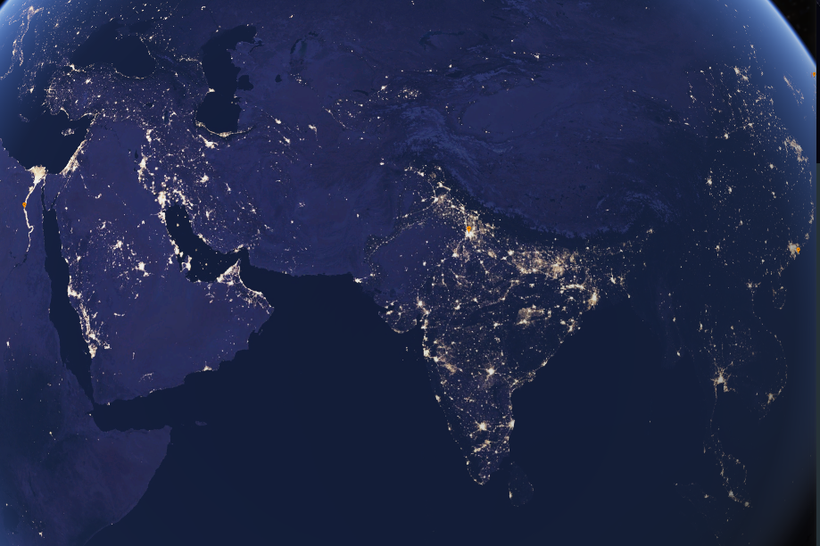
Task 3 - Follow the link on geographypods to take you to the night view of planet earth. Adjust the view so that you have a view that covers most of the area impacted by the new Silk Routes (see above).

i. What does the presence or absence of artificial light tells us about certain areas on Earth?

ii. What does that mean for the 'Belt' routes?
iii. Now, 'turn the lights on' and do some more research on some of the physical (natural) features that could prove to be difficult to cross. Record your research in the table beneath. An example has been completed for you. If you click on the image, it takes you to a Google 360° photo.
You can also add two political situations that could make the journey difficult between key countries.

Photo | Issue | Description of issue | Why it could cause difficulty.
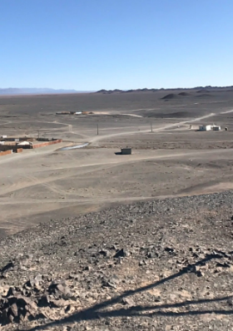 | The Gobi | Between Lanzhou and Urumqi, the New Silk road crosses the southern edge of the Gob desert. | The very dry conditions and blowing sand could cause the road to be blocked. The area is very remote and if you were to break down in your lorry, it could take a long time to be rescued.
 | Tian Shan
Iran
Link here
Belarus
Link here

