G6 Geography – The New Silk Roads

Task 2 – Using the embedded map on geographypods as your guide, sketch out the approximate routes of the following on the map:
Route | Key | Tick when complete
Silk Road Belt (overland) | Black line
Silk Road (ocean) | Blue line
Oil pipelines | Green line
Gas pipelines | Red line
All entry points for railways lines (in and out of China). | A star

Now add on the names of key cities along each of the routes.

Why are the Chinese government building pipelines to carry oil and gas from surrounding countries into China?

Complete the fact box below using the text on geographypods to help you.
How many countries are going to be connected by this initiative?
How much of the total population of the world does that account for?
How much of the total global GDP does that account for?

Try to think of four reasons why China wants to develop its global reach by strengthening and reopening some of these old trade routes. Look carefully at the places being connected. Record your ideas on the spider diagram below.

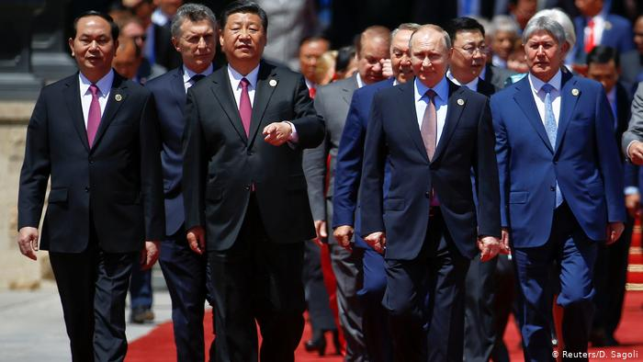
A meeting of the leaders of the Silk Road countries.

Watch the Music Video. This was made by the Chinese governments and features a group of children (from the different countries impacted by the New Silk routes) singing a lovely song.

What do you think about the content and the images in this official video?

In the space around the screenshot below, write down all the positive things that are talked about in the video.

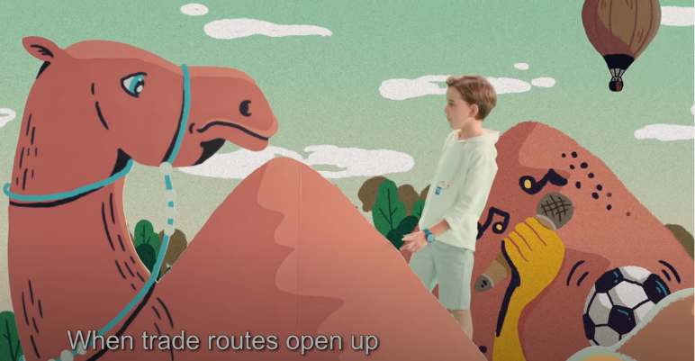

Finally, watch the embedded Vox video on geographypods. This video sums up everything we have learnt about so far. If you hear anything new or interesting, make a note of it in the space beneath.

