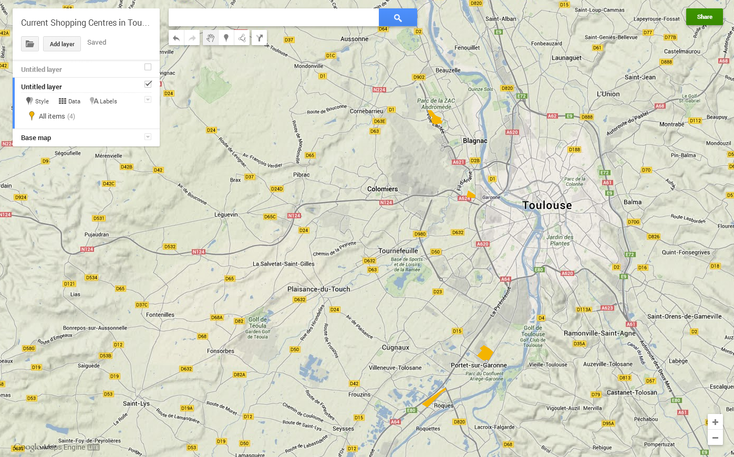
Sphere of Influence of Current Shopping Centres and Toulouse CBD.
Study the map of Toulouse and the surrounding area to the West. Look carefully, and you will see the current shopping centres marked as yellow blocks. The location of the proposed Val Tolosa Centre Commercial is marked as an orange dot.
Draw speheres of influence around Blagnac/Purpan & Portet/Roques. Then draw a sphere of influence around Val Tolosa. Some of the spheres may overlap.

