IGCSE Geography – Tropcial Storms – Hurricane Matthew 2016
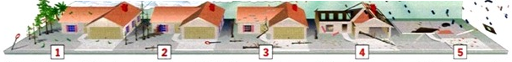

Category 1 | Category 2 | Category 3 | Category 4 | Category 5
Wind Speed & damage to property

Likely dangers to people

Impact of storm surge

Task 1 – Using the hurricane strength video, use the first box to record the wind speed and damage to property. The second box should include the likely dangers to people in each of the categories and the third box should include details of impact of ‘storm surge’.

