Populations in transition
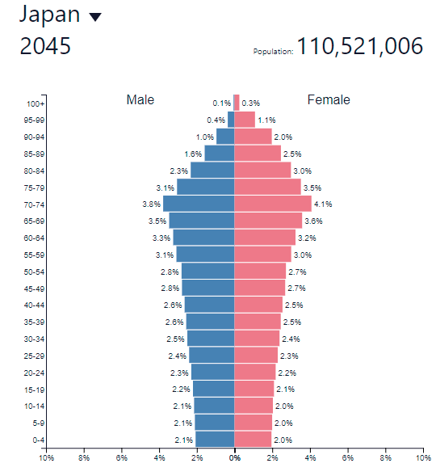

- Describe the age structure of the projected population of Japan in 2045. ________________
__________________________________________________________________________________________________________________________________________________________________________________________________________________________________________
2

- Explain the economic impacts of an ageing population on a named (other than Japan) country. ________________________________________________________________________________________________________________________________________________________________________________________________________________________________________________________________________________________________________________________
2

- What type of natalist policy (pro or anti) chould be attached to an ageing society? ___________________________________________________________________________
1

- Using a named country, evaluate a process that has been implemented for any type of natalist issue to alter the future population possibility.
____________________________________________________________________________________________________________________________________________________________________________________________________________________________________________________________________________________________________________________________________________________________________________________________________________________________________________________________________________________________________________________________________________________________________________________________________________________________________________________________________________________________________________________________________________________________________________________________________________

(5)
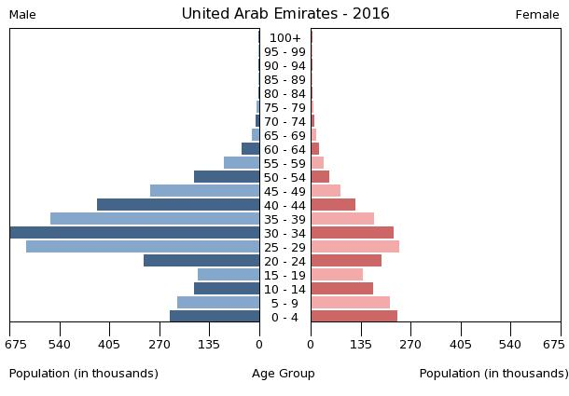

Why is the structure above not natural? What has caused this imbalance?

Dependency Ratios
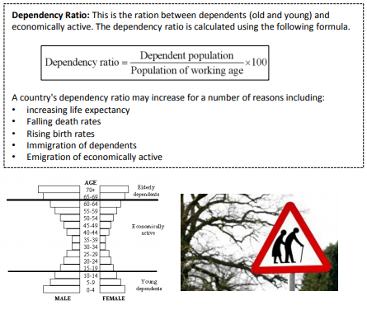

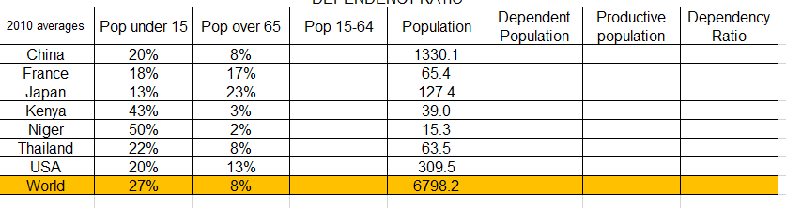
Spend a little time filling in three of the countries below to work out the dependency ratio.

Migration:

Define Forced Migration _____________________________________________________________________________________________________________________________________________________________________________________________________________________________________________________________(2)

Define Voluntary Migration _____________________________________________________________________________________________________________________________________________________________________________________________________________________________________________________________(2)

Briefly explain two positive socio-economic impacts that migration could have for the provinces of origin. [2+2]
__________________________________________________________________________________________________________________________________________________________________________________________________________________________________________________________________________________________________________________________________________________________________________________________________________________________________________________________________________________________________________________________(2+2)

Outline the differences between a refugee and an economic migrant.
__________________________________________________________________________________________________________________________________________________________________________________________________________________________________________________________________________________________________________________________________________________________________________________________________________________________________________________________________________________________________________________________(2+2)

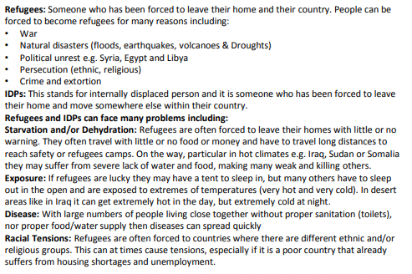

Gender – Inequalities (not just Saudi Arabia remember – look beyond the obvious!)
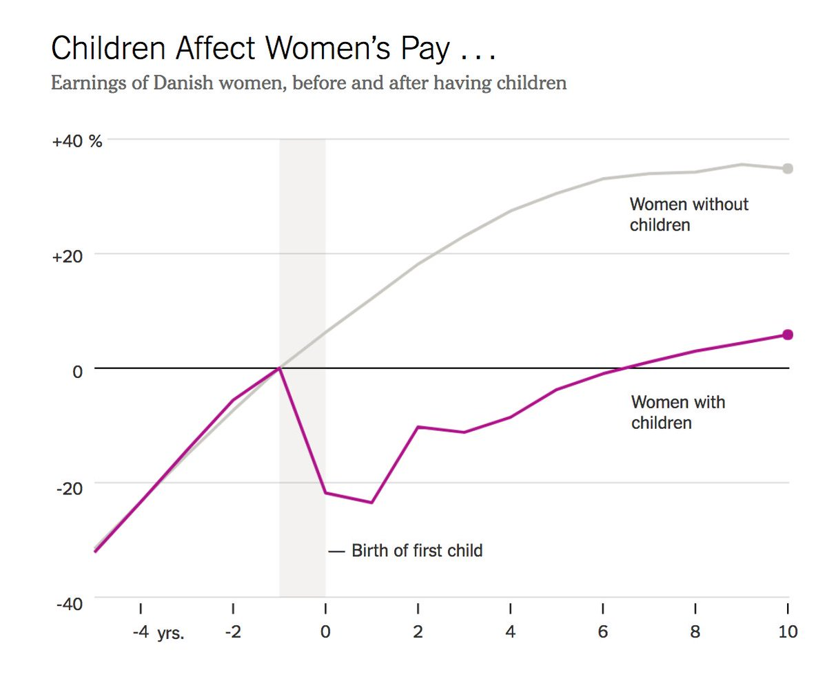

Annotate this graph with as much information as you can referring to gender inequalities in culture, status, education, birth ratios, health, employment, empowerment, family size and legal rights

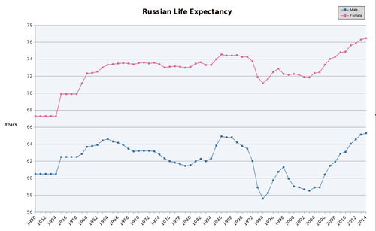

State two factors that men have a lower life expectancy in Russia than women
1 __________________________________________________________________________________
2 __________________________________________________________________________________

Legal rights & land tenure (preparing for the question that has never been asked).
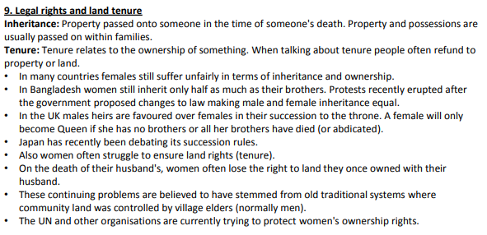
Unit 2 - Disparities in Wealth & Development
Explain one strength and one weakness of using the GNI as a way of measuring disparities. [2+2]
__________________________________________________________________________________________________________________________________________________________________________________________________________________________________________________________________________________________________________________________________________________________________________________________________________________________________________________________________________________________________________________________(2+2)

What’s the difference between GDP, GNP & GNI?
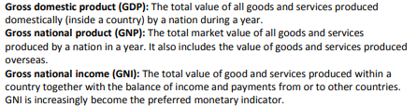

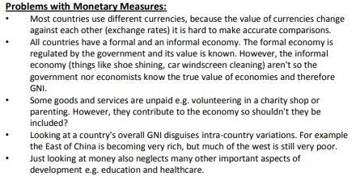
More to life than money…

Marginalization: When a group of people become separated from society. Marginalized populations are those excluded from mainstream social, economic, cultural, or political life. Examples of marginalized populations include, but are by no means limited to, groups excluded due to race, religion, political or cultural group, age, gender
Explain how marginalization of a population has occurred using one case study example.
__________________________________________________________________________________________________________________________________________________________________________________________________________________________________________________________________________________________________________________________________________________________________________________________________________________________________________________________________________________________________________________________(4)

Explain how inequalities can arise from land ownership in one named country.
____________________________________________________________________________________________________________________________________________________________________________________________________________________________________________________________________________________________________________________________________________________________________________________________________________________________________________________________________________________________________________________________(4)
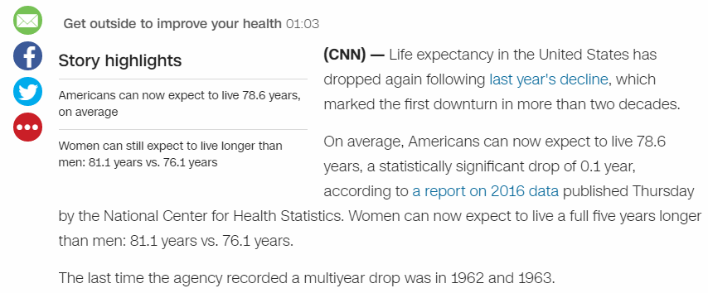

Explain two possible causes of a reduction in life expectancy in the USA.
__________________________________________________________________________________________________________________________________________________________________________________________________________________________________________________________________________________________________________________________________________________________________________________________________________________________________________________________________________________________________________________________(2+2)

Briefly explain how trade & market access can reduce global disparities. [4]
____________________________________________________________________________________________________________________________________________________________________________________________________________________________________________________________________________________________________________________________________________________________________________________________________________________________________________________________________________________________________________________________(4)

Outline one way that trade and market access can bring about negative impacts on a place
__________________________________________________________________________________________________________________________________________________________________________________________________________________________________________________________________________________________________________________________________________________(2)

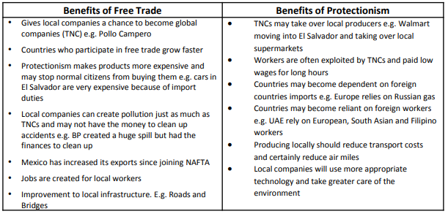

Environmental Quality & Sustainability

Define Insolation
________________________________________________________________________________________________________________________________________________________________________(1)

Define Longwave radiation
________________________________________________________________________________________________________________________________________________________________________(1)

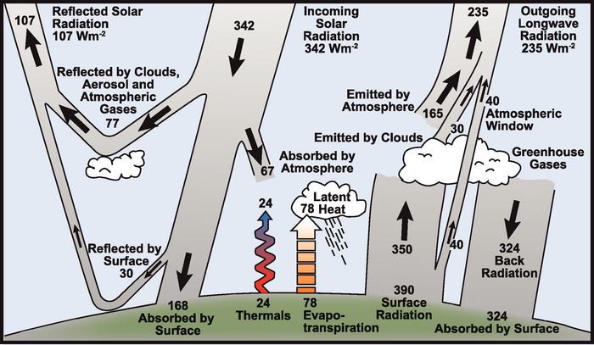
Identify and explain one factor that can impact on the amount of longwave radiation emitted back into space.
__________________________________________________________________________________________________________________________________________________________________________________________________________________________________________________________________________________________________________________________________________________(2)
Explain two socio-economic consequences of soil degradation. [2+2]
__________________________________________________________________________________________________________________________________________________________________________________________________________________________________________________________________________________________________________________________________________________________________________________________________________________________________________________________________________________________________________________________(2+2)

Define the term ‘Economic Water Scarcity’
________________________________________________________________________________________________________________________________________________________________________(1)

**Possible 15 mark question**

- Examine how the factors affecting access to safe drinking water are linked to rapid population growth in different parts of the world.
Examine (AO3): Consider an argument or concept in a way that uncovers the assumptions and interrelationships of the issue

Note the cross over between two different parts of the core unit.

- Compare and contrast the effectiveness of an environmental quality improvement scheme a resource reduction strategy at a local or national scale designed to achieve environmental sustainability.
Compare and contrast (AO3): Give an account of similarities and differences between two (or more) items or situations, referring to both (all) of them throughout

Patterns in Resource Consumption
Explain the difference in the viewpoints of anti and neo-Malthusian attitudes towards the relationship between population and resource consumption. [4]
____________________________________________________________________________________________________________________________________________________________________________________________________________________________________________________________________________________________________________________________________________________________________________________________________________________________________________________________________________________________________________________________(4)
Outline a strategy at a local or national scale which is designed to reduce the consumption of one named resource. [2]
__________________________________________________________________________________________________________________________________________________________________________________________________________________________________________________________________________________________________________________________________________________(2)
Explain two reasons why the strategy described in (c)(i) either has or has not been a success. [2+2]
__________________________________________________________________________________________________________________________________________________________________________________________________________________________________________________________________________________________________________________________________________________________________________________________________________________________________________________________________________________________________________________________(2+2)

