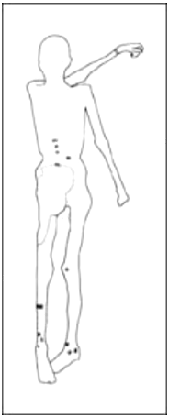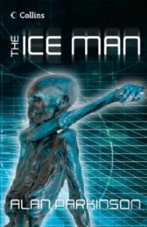 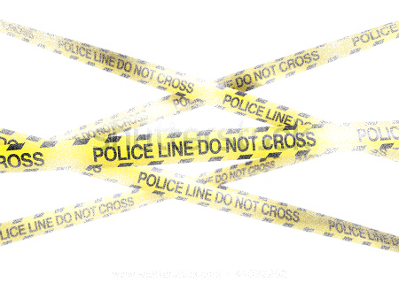

2. Using the Google Earth link, describe the landscape surrounding when the body was found.

3. Using the picture on page 3, describe the body and sketch the details onto the blank body in the centre of this sheet.

5. Is this an unusual occurrence in the part of the world? Why?

4. Witnesses – who found the body? Name & nationality.

1. Using the Google Map, where exactly was the body found? Make sure you name the country too!

**Location & Identity Report – The Ice Man**