Plotting Plate Boundaries - Grade 6 Geography

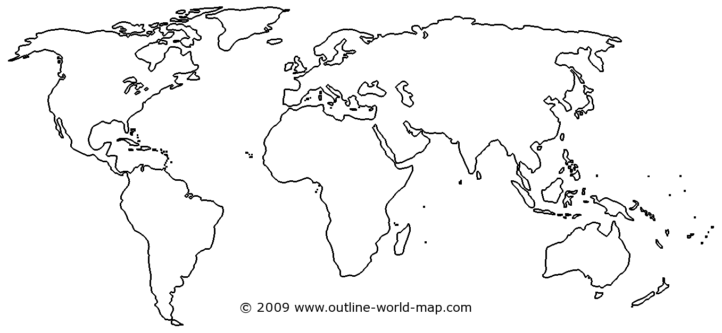
Europe Centred Map

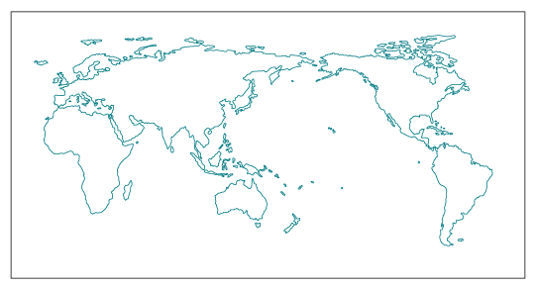
Pacific Centred Map

