Year 8 Geography – Planning the Great Solo Sinkhole
Task: Annotate and design in detail how your Solo Sinkhole model will work using your cartoons and the information on www.geographypods.com
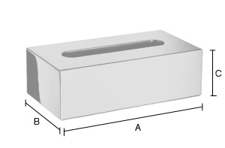

List of equipment and additional materials from home:

