Niagara Redeveloped – Checklist & Instructions
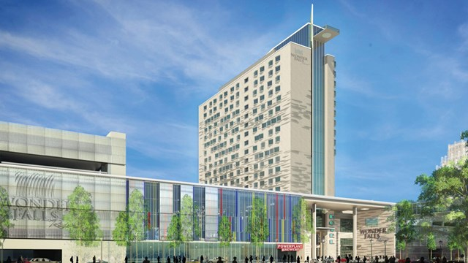
Checklist Table
Environmental Sustainability Schemes | Economic Sustainability Schemes | Social Sustainability Schemes

Energy Checklist | Type | % make up
Total |  | 100%

Brief
You have created your own development company and created a brand logo and slogan. You are working against your competition, Uniland and their proposal called Wonderfalls. You have been given a budget of $4 million to redevelop the Rainbow Shopping Mall and have a shortlist of possible sustainable schemes to regenerate the site, improve the environment and create jobs and prosperity in the local area.

