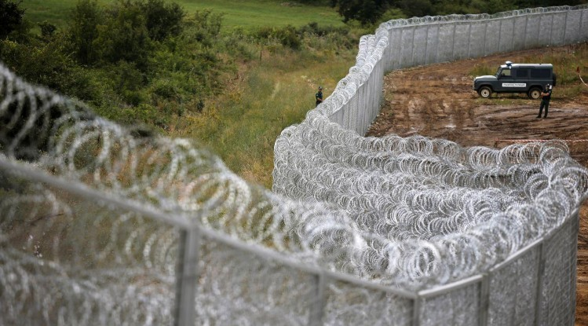**The #Refugeecrisis in the EU**

**Are refugees welcomed in all countries?**