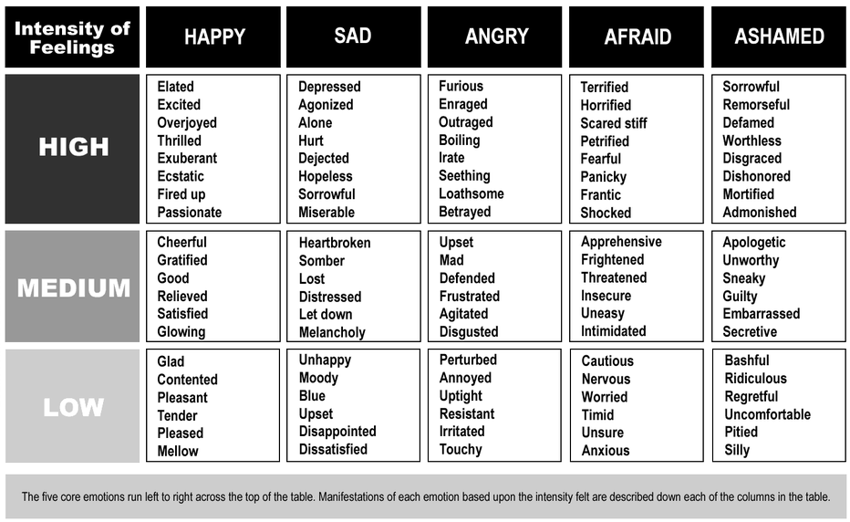
Which one word sums up your feelings on the current refugee crisis?
Put your initials next to the one that you are drawn to.

