The #Refugeecrisis in the EU
Interpretation by the artist - Banksy.
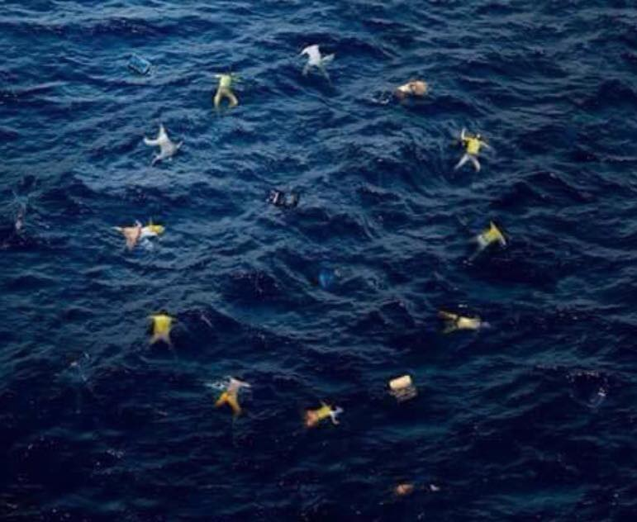
Have you been watching the news?

