Grade 7 Geography - Mapping Out Recent Sinkholes – Resources Sheet
Guatemala City Sinkhole 2010
What Happened?
Use this resource sheet to create your own worksheet that shows global locations of sink holes.
Task 2
Step 1. Using Google Maps, find the location of each of the three sinkholes named in the blue boxes.
Step 2. Drag the blue box and the photo near to the location and connect them to the location on the map with a blue arrow.
Step 3. Use your internet research skills to find out what happened at each site and if anyone was injured or killed.
Task 3 – What do you notice about the location of Karst and the location of sinkholes?
Step 4 – Where is your closest sink hole danger area?

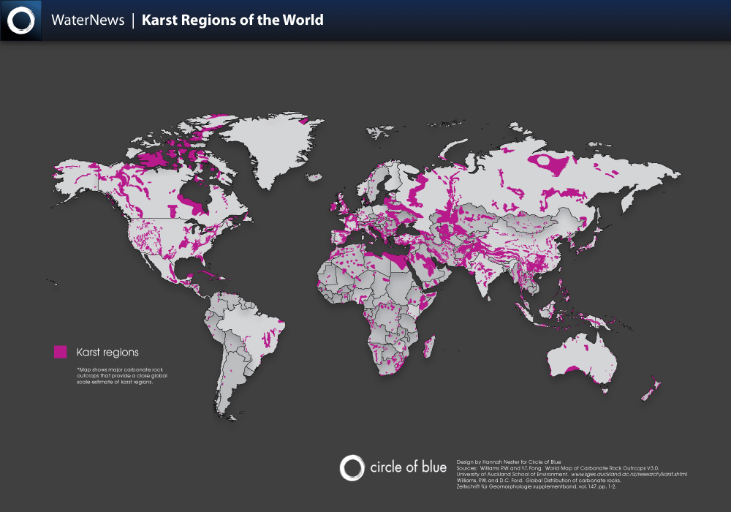

Guangdong Province, China. Sinkhole 2013
What Happened?
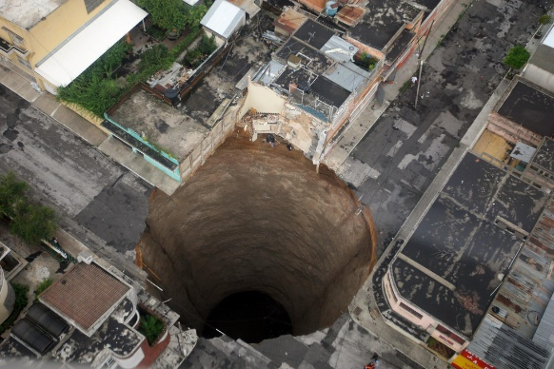
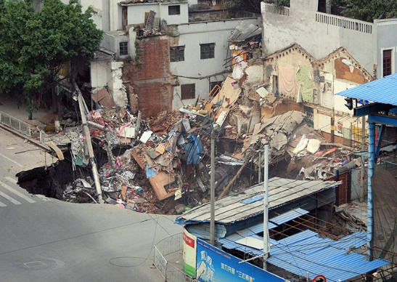
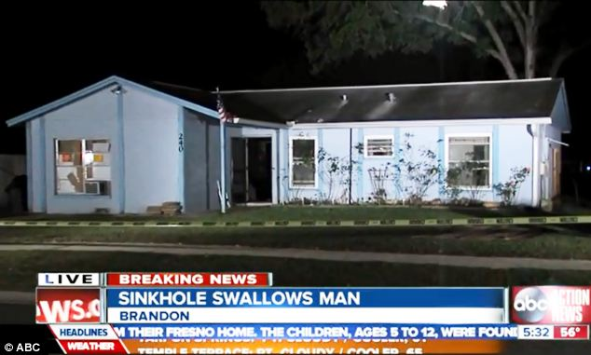
Florida Sinkhole, USA 2013
What Happened?

