Year 8 – Out of Town Shopping Centres
Routes to Val Tolosa from surrounding settlements

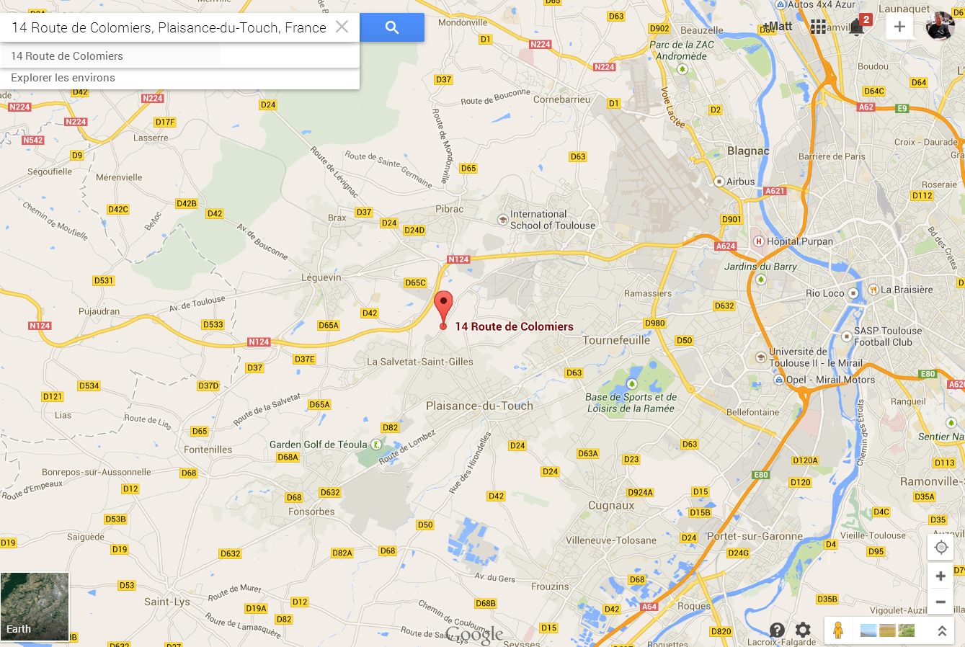

- With a colour pen, copy out the routes from Google Maps from each of the 11 locations on the previous worksheet
ii. Which roads would be commonly used to access the new Val Tolossa Centre Commercial?

iii. Annotate onto the maps areas where you think traffic jams could be a problem.
iv. In the space below, create a spider diagram of the different ways that Val Tolosa could try and reduce congestion in the surrounding area?
Reducing Congestion around the Val Tolosa Centre Commercial

