G7 Geography - Life in the Shadow of US-Mexico border Wall – Video Task
Watch the video presented by Juan Paullier and take some basic notes on each of the locations visited. You can switch the subtitles on if you need them.
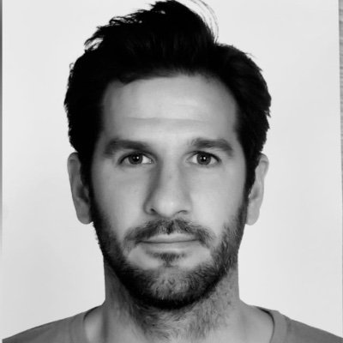
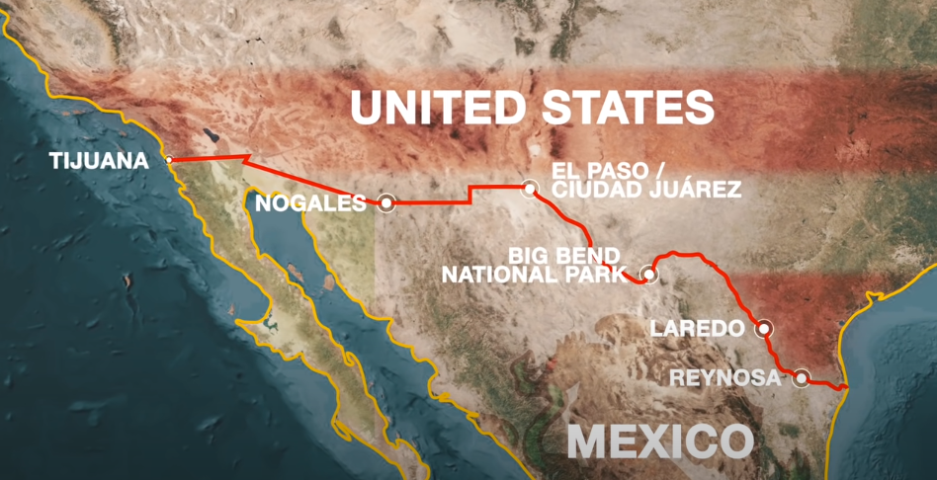
Estimated number of undocumented immigrants in the USA = ____ million

Which location is the most dangerous? ___________________

Which part of the documentary was the most memorable for you?

Name of town(s) | Reynosa  1:10 | Laredo  15:50 | Big Bend  National Park - 17:40 | El Paso /  Ciudad Juarez 21:45 | Nogales  26:44 | Tijuana  32:27
One important piece of information
One important piece of data
Something important that someone said (a quote)
How dangerous 1-10 to cross
1-no danger 10-Deadly
How difficult 1-10 to cross
1-easy 10-impossible

https://www.youtube.com/watch?v=r9Gd-axMMbM

