World Cup 2022 – How has Qatar Changed?
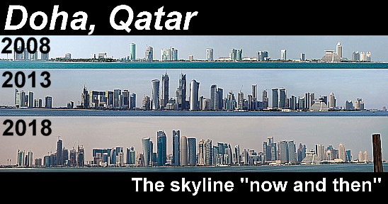

Each place has a function. The function of a place is what the place is known for or what it produces. The function of Qatar has changed a lot over history. Watch the video embedded on geographypods and complete the brief note taking exercise below.
Function / key events in Qatar | Brief description
Make some notes on Pearl Diving and how people collected these precious items.
What happened on December 18th, 1878?

What happened in 1916? When did this change last until?
What happened in 1925?

What was discovered in 1939 & what stopped this from being exploited?

Using this resource, take a look at how the built landscape in Qatar has changed in the last 50 years. Choose any two of the slider images and take a screen shot of the before and after. Paste them into the space provided and write a short description about the changes you can see.

Before | Now
Written Description of the changes.

Before | Now
Written Description of the changes.

