G7 Geography – Walls in our locality
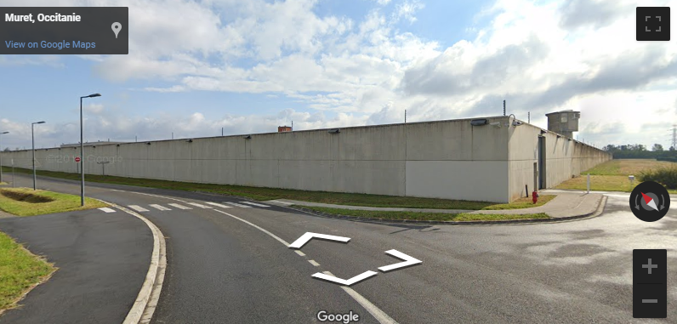
Task 3 - Use the embedded image on geographypods to answer the following questions.

What is this place?

What is on the other side of this wall?

Is this wall to stop people getting in, or getting out?

Would it be easy to get over? Why?

Apart from a wall, how else is this place protected?

Now try to view this place on Google Maps using satellite view using these - 43.48510556741294, 1.32346049714676

​Why is this area blurred out on Google?

Bio Polar Analysis – This large concrete wall!
Barrier Characteristics | Very poor | Poor | Quite poor | No feelings | Quite good | Good | Very good | Total
 | -3 | -2 | -1 | 0 | +1 | +2 | +3
Height
Condition
Well made
Long lasting
Visual deterrent

Total:
Notes on this site. Open, exposed, hidden, visible, close to road, private housing etc.

On a scale of 1 (simple) to 10 (impossible), how easy would it be to cross this barrier and get in to / out of school?
1 | 2 | 3 | 4 | 5 | 6 | 7 | 8 | 9 | 10

