G7 – Barriers & Walls Homework
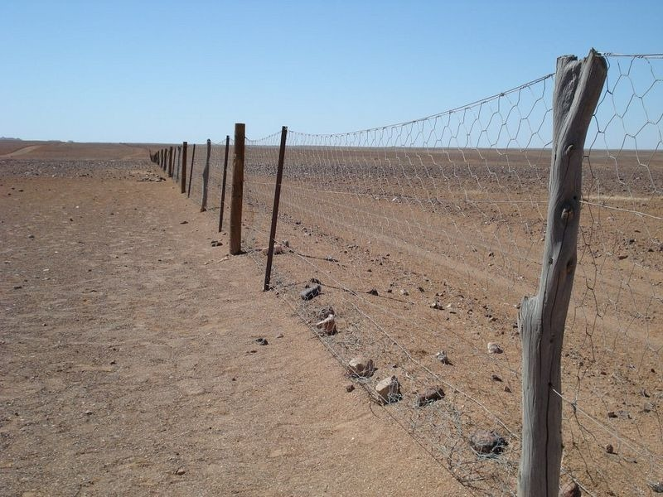

The image above just looks like a random fence, right? ………..Wrong!

It is world famous and has a serious claim to fame! But where is it? When was it built? Why was it built and how far does it stretch for?

Produce a research fact file on the following page that answers the questions above and includes at least one additional photo and one map. Target 30 mins.

You have one clue only to get you started. The rest is up to you.
It is located somewhere on the driest inhabited continent on planet earth.
Fact file Homework Task

Country
Describe where the barrier is
When was it built?

What was the original name of the barrier?
What is the barrier called today?

What was it built to stop & why was this a problem?

Does it still have the same purpose today?
How long did it take to construct?
How much did it cost to construct?

How far does it stretch in KM?
Why is it still there today?

Map to show location (paste below)

