Grade 8 Geography – Ecosystems, Biomes & Habitats
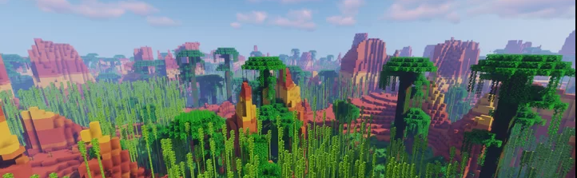

Using the National Geographic infographic, define an ecosystem.

Using the National Geographic infographic, define a biome.

Using the National Geographic infographic, define a habitat.

What is the major differences between an ecosystem and a biome?

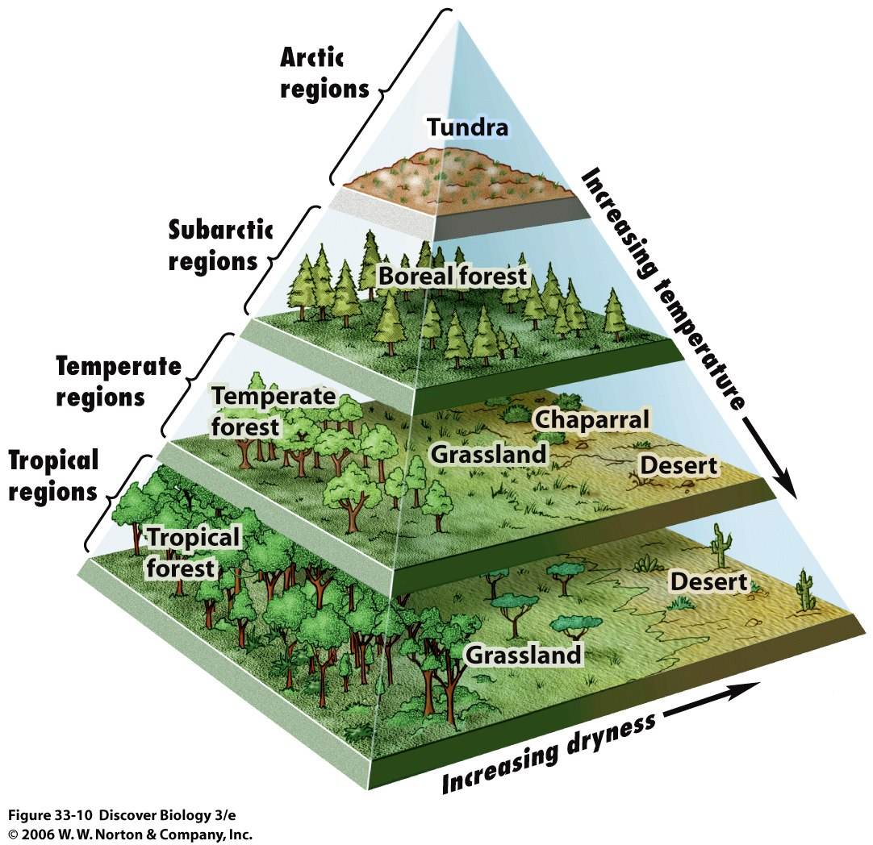

Study the diagram above and answer the following questions.

Which biome do you get when…
It is very dry and there are very high temperatures?
It is very wet and there are very high temperatures?
It is very cold and there are very low temperatures?
There are mid-levels of dryness and very high temperatures
Deserts and grasslands can occur in which two regions?
Which biome region do you think we live in?

Which one of the biomes above is the most perfect place for plants, animals, and insects to thrive?

