Grade 6 Geography - Tornadoes
Task 1 – Study the imagery carefully. You have 10 minutes, what will you do?

Your parents aren’t yet home from work. You are at home playing in the garden, when you hear a strange noise. You turn around and see this….

Do you run? Do you head towards the house? Do you run to your neighbours? Do you gather anything precious? Do you try to save anything?

Task 2 - You have less than 5 minutes, where will you go?

You are stood in front of your house? You are in for a direct hit. Stay outside? Run inside? If inside, where do you go? What do you take with you?

Then the tornado strikes!
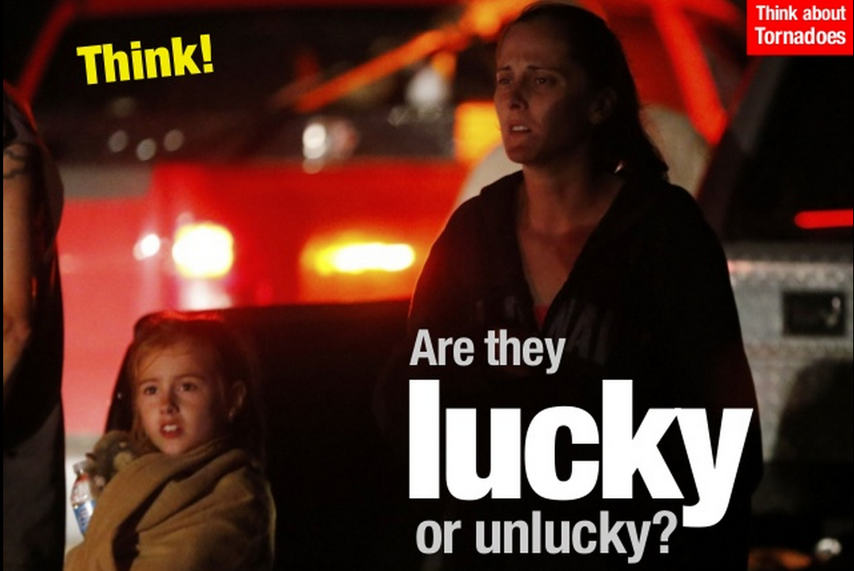

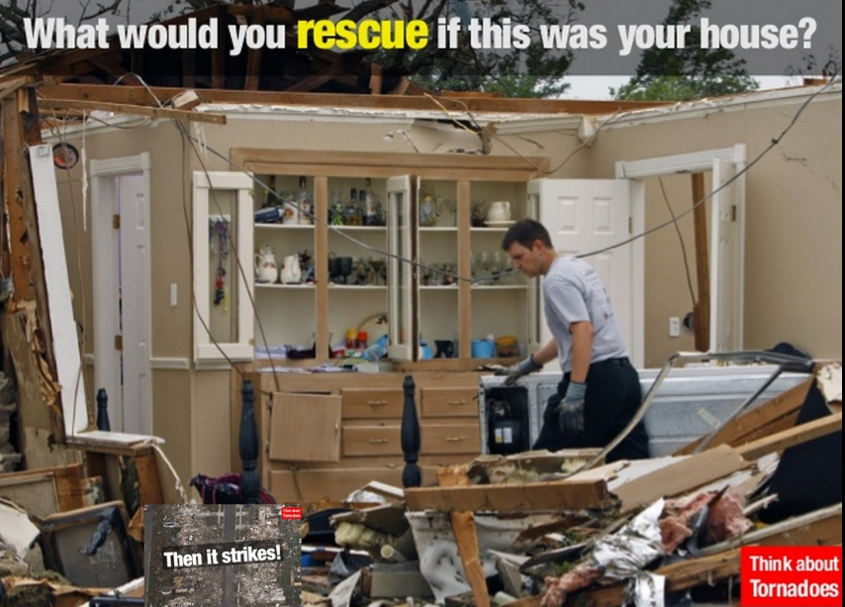

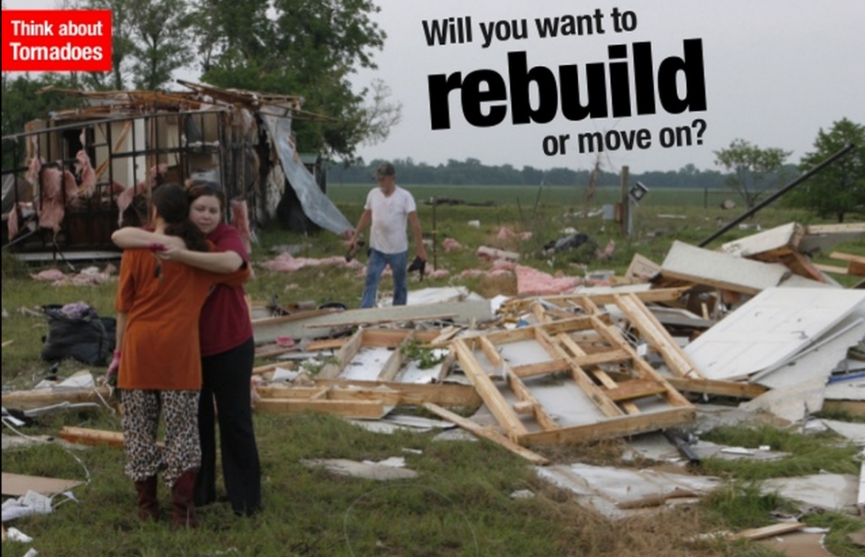

Write down your feelings about tornadoes using at least 10 different adjectives. Underline each adjective.

