Graphing Population Change – 2013 ‘Don’t Panic’ Documentary
Using the BBC documentary starting at 3.40 showing Population Growth from 10,000BC . Pay particular attention to the section from 1800 to present day.
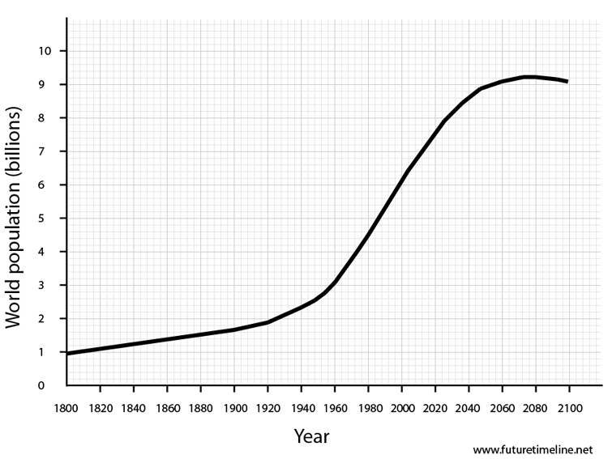

- What was the catalyst of the change in 1800?

- Mark on the dates of each of the 7 population milestones so far to 2013. Use this link to help you.
- Mark on the estimated dates of future population milestones using the graph and the link in activity 2.
- Mark on your date of birth

- How many population milestones have you lived through – a) up until today and b) will you live through in terms of your total life expectancy for your country of residence? (click this link to find out)

- Complete the table below:
Population Milestone | Year | Years to get to that from previous milestone
1 Billion
2 Billion
3 Billion
4 Billion
5 Billion
6 Billion
7 Billion
8 Billion
9 Billion

- Describe the historic and future population trends from the graph and table above referring to dates and population numbers.

