G7 Geography – Planning My Globalization Essay
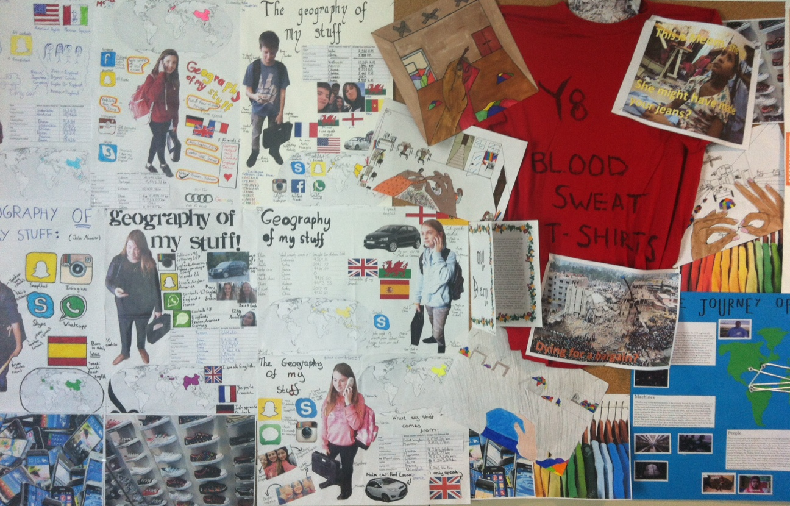
This is our end of unit essay assessment. It is a formal assessment and the focus should be on you and your lives! This means that you get to write all about yourself and how you have been shaped by the different processes of globalization.
You may use personal examples, your own photos and even get your parents and family involved if they would like to be part of your essay. As a student at an international school, speaking languages that might not be your native tongue and in a country where you may not have been born immediately sets you apart from many other G7 students around the world.
In this essay, you should aim to complete the following requirements:
At least 800 words
10 images / photos
At least 7 images / photos above should be ones that you have taken.
At least one map
One short interview with someone else
Reference to one film
Reference to one song / music group
Reference to a sports team
Reference to your favourite article of clothing.
One paragraph of work written in another language that you are proficient in.

Please do not submit this template as your essay. You must write an essay using Word using this structure sheet as a guide and include the content within. The work will be graded / 100.

Paragraph 1 – Introducing me, my globalized world and my family.
- Why are we in France?
- Where have we lived before & Why did we move?
- Map of places that I have been to.
- Languages & Nationalities?
- Hint: You might want to use several images* here and a copy of your ‘Geography of my stuff poster’.

Paragraph 2 - What does the word Globalization mean?
- Here is a definition
- How do I put that into my own words so that it is meaningful to me?

Paragraph 3 - What helps to spread Globalization? Here is the theory. What helps people to:
- Share & Connect
- Buy
- Download
- Travel
- Afford stuff
- Learn
- Eat
- Speak different languages etc?

Paragraph 4 - What are the advantages/positive things about globalization?
- Here is the theory.
- But, how do me and my family benefit?
- What things could I not ‘live’ without?

Paragraph 5 - What are the disadvantages/negative things about globalization?
- Here is the theory
- Who does not benefit from globalization?
- How does globalization affect me / other people in a negative way?
- Think about what you have learnt about other parts of the world.
- Think about the environment, cultures, working conditions and money.

Paragraph 6 - Conclusion - What conclusions can you make about globalization?
- Does it make your life better or worse?
- Is that the same for everyone no matter where they live?
- Could you live without it?
- What do you rely on the most?
- How has Covid-19 impacted on globalization?

