G6 Geography – Where are the volcanoes?
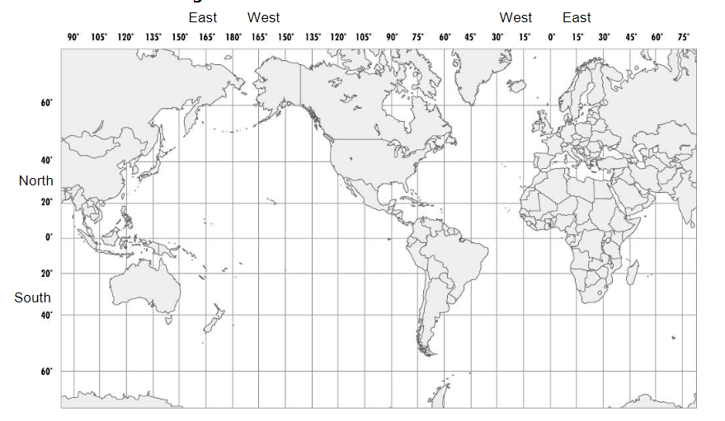

Plotting Volcanic Activity: The table below shows 20 volcanoes by their latitude and longitude. Plot each location on the map above. Mark each volcano by writing its number where you have plotted it to be on the map.

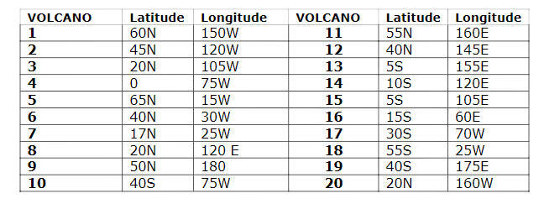
Source: https://studylib.net/doc/7518110/lab-plotting-volcanoes

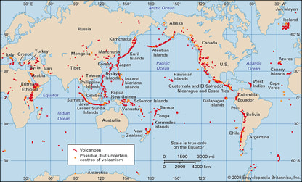

Map 1 - This map shows all the volcanoes in the world. Look carefully and you will see the Pacific Ring of Fire.

​i. Where are most volcanoes found in the world?
ii. How might this link into plate boundaries? (Think back to the last unit of work on tectonics).

Approximately, how many KM does the line of volcanoes that makes up the Aleutian Islands (southwest of Alaska) stretch for?

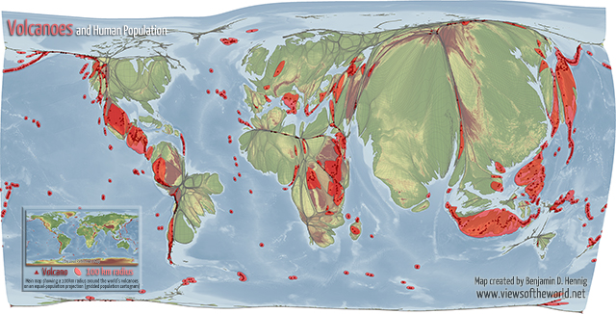
Map 2 – The inflated countries are those that have high populations. The deflated countries have low populations. Check out China (high) and Australia (low).

The map shows how human settlement patterns and the global distribution of volcanoes correlate by drawing a 100km radius around each of the world’s volcanoes and then projecting this data onto a gridded population cartogram. This equal-population projection results in some of these 100km risk zones around the volcanoes to become really visible.

i. Are there any areas that have high populations and a high risk of volcanic activity?
ii. Can you think of any reasons why people might want live close to volcanoes?

Which country looks to be the riskiest
in terms of volcanic activity?

