G6 Richter Scale – Information Sheet

Scientists use a Richter scale to classify earthquakes. The damage increases as the movements of the ground increase in size. The difference between one whole number of magnitude and the next is a 10-times increase in energy. So, an earthquake of 6.0 magnitude releases 10 times more energy than an earthquake of 5.0 magnitude
Humans may be able to feel a magnitude 3 quake if they were sitting still and there were no other noises. The Richter Scale goes from 1 – Greater than 9. Complete the calculations below.
Richter Scale Level | How many times more powerful than a 3? calculations here | Final Answer
1

2

3 * We can feel a quake at this level
4 | 3 to 4 = 1 x 10 = | 10 times as powerful
5

6

7 *This is the video on geogaphypods
8 | 3 to 8 = 10 x 10 x 10 x 10 x 10 = | 100,000 times as powerful
9

10

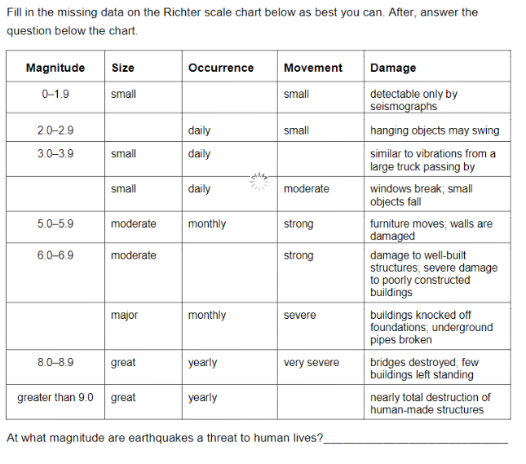
Find out about the strongest ever quake recorded and record the details of it (where, when, what happened) in the space below.

