Freshwater – Option A – Higher Level
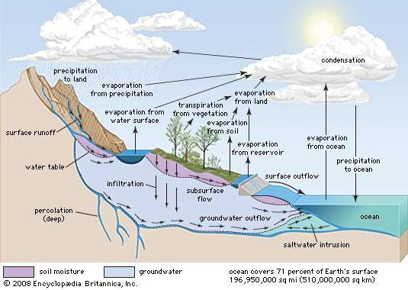

Identify two transfers and two stores shown in the diagram. (2x2)
_____________________________________________________________________________________________________________________________________________________________________________________________________________________________________________________________________________________________________________________________________________________________________________________________________________________ (2+2)
Outline how water is transferred through a drainage basin by:

Groundwater flow [2]
______________________________________________________________________________________________________________________________________________________________________________________________________________________________________________________
Surface Runoff [2]
______________________________________________________________________________________________________________________________________________________________________________________________________________________________________________________

Suggest how a decline in ice coverage in mountain areas on the diagram could result in changes to surface runoff.
____________________________________________________________________________________________________________________________________________________________________________________________________________________________________________________(2)

Identify one positive and one negative feedback loop that could exist in an inhabited drainage basin
____________________________________________________________________________________________________________________________________________________________________________________________________________________________________________________(2)
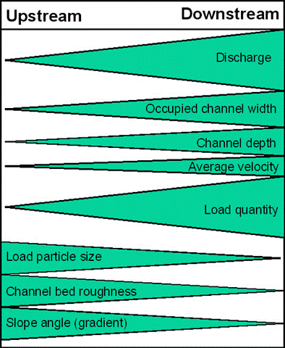

Explain how stream discharge is related to channel size and shape. (6)
______________________________________________________________________________________________________________________________________________________________________________________________________________________________________________________________________________________________________________________________________________________________________________________________________________________________________________________________________________________________________________________________________________________________________________________________________________________________________________________________________________(6)

State two possible uses of water for agriculture. (2)
______________________________________________________________________________________________________________________________________________________________________________________________________________________________________________________

International conflicts for water are more difficult to mitigate against than those at a regional scale. To what extent do you agree with this statement? (10)
_____________________________________________________________________________________________________________________________________________________________________________________________________________________________________________________________________________________________________________________________________________________________________________________________________________________________________________________________________________________________________________________________________________________________________________________________________________________________________________________________________________________________________________________________________________________________________________________________________________________________________________________________________________________________________________________________________________________________________________________________________________________________________________________________________________________________________________________________________________________________________________________________________________________________________________________________________________________________________________________________________________________________________________________________________________________________________________________________________________________________________________________________________________________________________________________________________________________________________________________________________________________________________________________________________________________________________________________________________________________________________________________________________________________________________________________________________________________________________________________________________________________________________________(10)

