G7 – 8850 – From the bottom of the ocean to the top of the world!
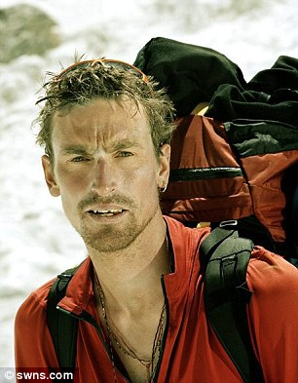
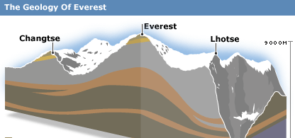

i. What are the three main layers of rock called that make up Mount Everest?

ii. What were the risks in collecting the samples?

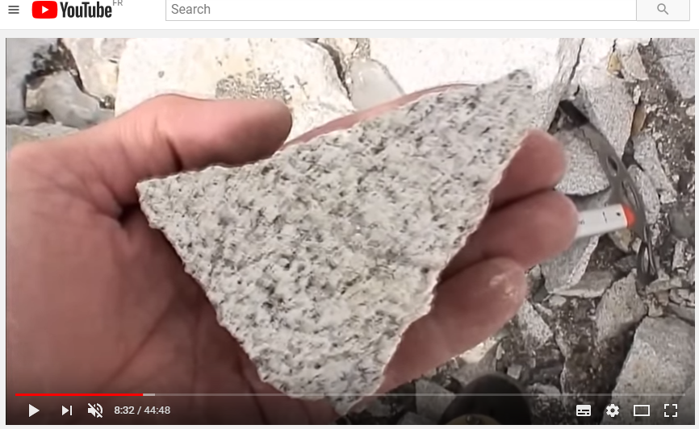

iii. What evidence exists to prove that this rock was formed under the oceans?

iv. Go back to the Red Bull highest base jump video on geographypods. Watch the sequence again very carefully and stop the video at any point where you can see evidence of these layers. Paste the screenshot into the image below and try and label them with information from the first task.
Paste image here (Ctrl V)

