Fertility - The Population Situation in a so-called LEDC - Bangladesh
Don’t Panic – BBC2 Documentary 2013
Starter – Click here to be taken to the GapMinder graph plotting GDP PPP v Fertility Rate for Bangladesh.
Task 1 - Below is a traditional view of a Bangladeshi family in the 1970’s & 1980’s. Annotate the photo beneath with details of fertility rates and GDP/Capita PPP around this time (hover over the trace and it will show you the values) together with the typical employment and living conditions.

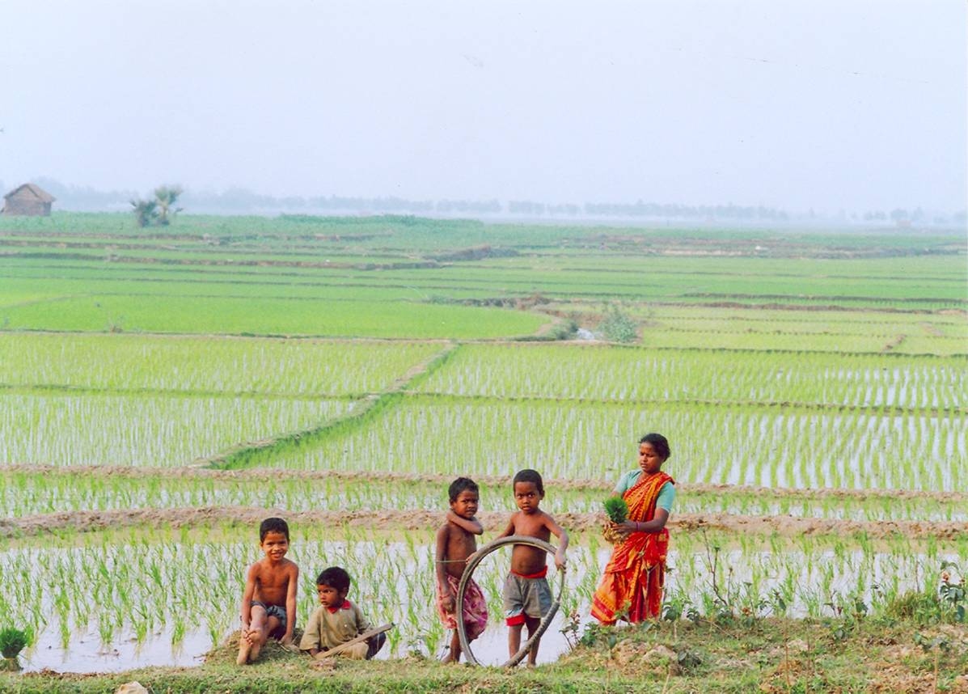

Task 2 – Describe the pattern in the fertility rate in Bangladesh between 1970 – 2012. Has this pattern in fertility been linked to a rapid increase in wealth (GDP PPP) during this time?

Task 3 – Outline the main reasons why Mr Khan has decided to just have two children.
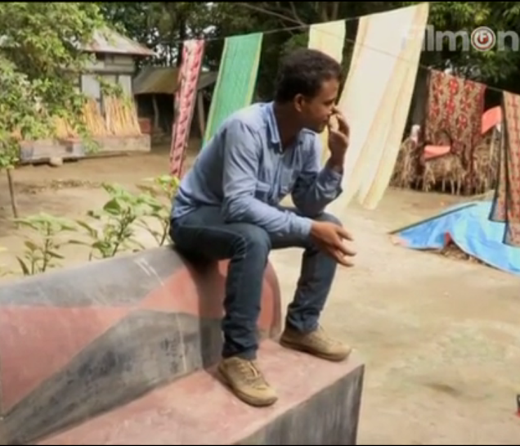
My choice was to have only two children because …

Task 4 – Outline how Taslima Khan in her job as a Health Worker aims to promote family planning. Can you identify any forms of gender inequality in the sequence?
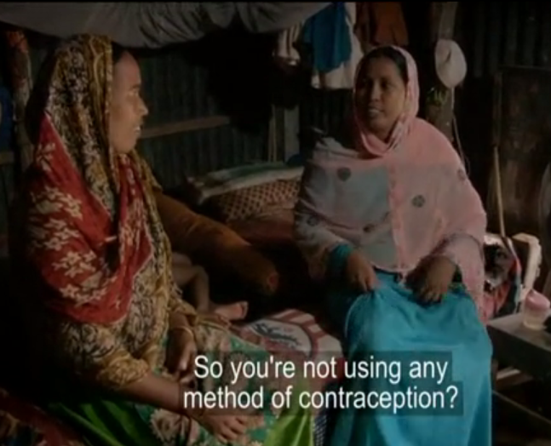

Task 5 – Using this GapMinder graph and the 3D visualization used by Hans Rosling in the video, explain what the situation was in 1963 (what was the average fertility rate) and how it has changed to 2012 (state fertility rate)

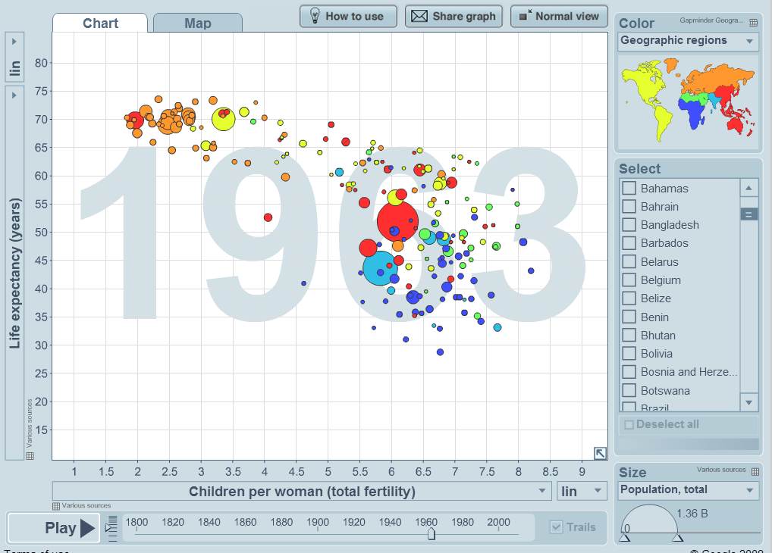
Task 6
- Using the Hans Rosling 3D sequence, highlight the clear divide the was visible in 1963 and circle the MEDC & LEDC clusters that existed at the time.
- Now try to identify patterns that exist in 2012.

- Can you name one region in the world that is still lagging behind the rest of the world in terms of tackling fertility rates?

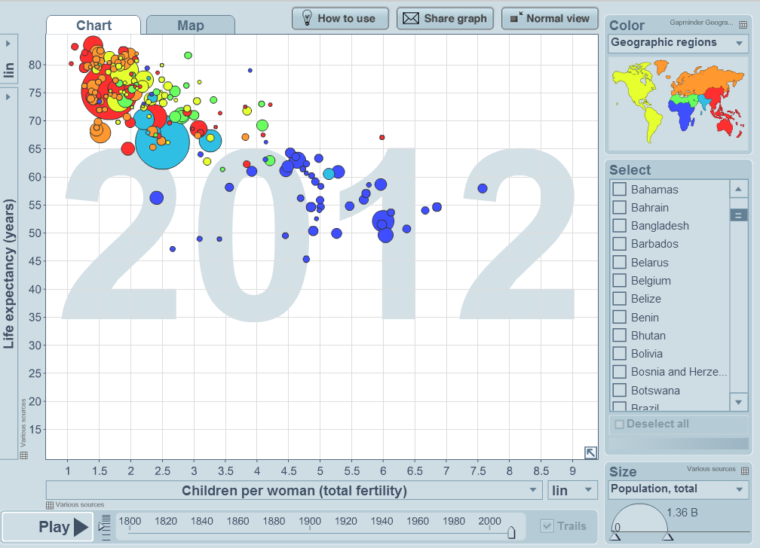

- In the video, Hans Rosling mentions other locations in so called developed countries (LEDC’s) that have drastically reduced their fertility rates. Note them here.

Task 8 – Hans Rosling argues that the Development Gap no longer exists. To what extent do you agree with his statement? Use the data you have studies as well as challenging your pre-conceived ideas in your response.

