EVEREST - Effects of Altitude Sickness on Humans.

Task 1 - Using geographypods and the information on Wikipedia, annotate the effects of the two different types of altitude sickness on the image beneath.

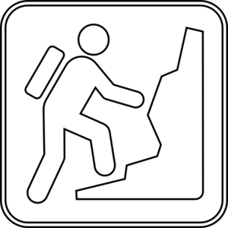

Brain Symptoms | Lung Symptoms

