G6 Geography – Living Close To Volcanoes
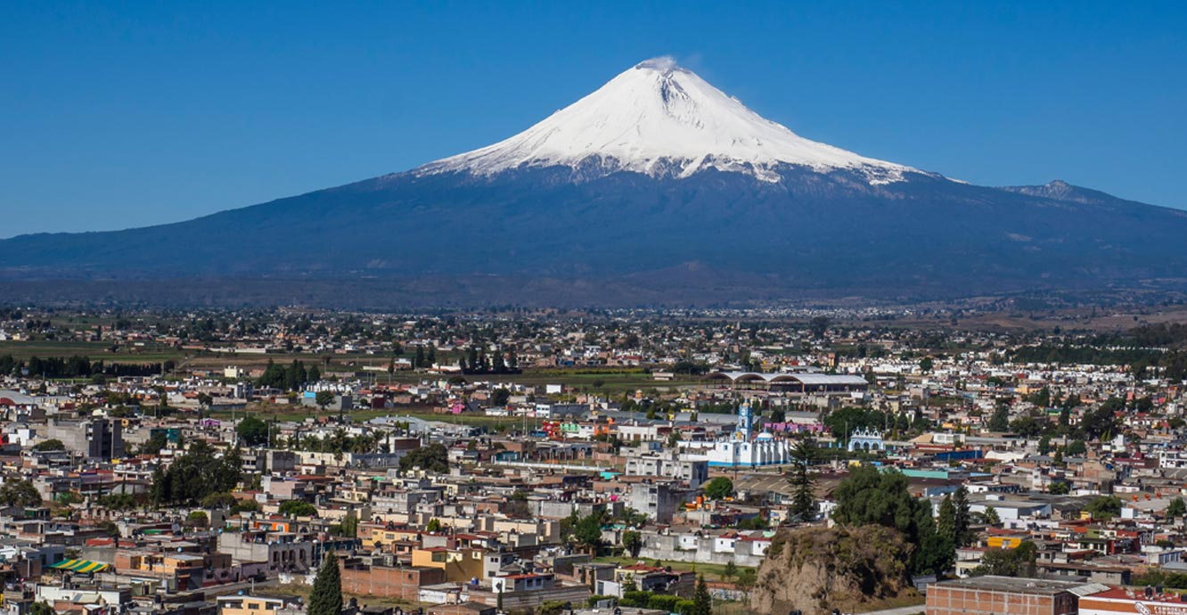
Source: British Geological Survey

Watch the video named ‘Volcano Benefits’ on geographypods. Answer the following questions

Benefit 1 – Fertile Soil
What three things does lava contain? | 1  2  3
How does this help farmers?
Benefit 2 – Land Creation
What % of the earth’s surface was created by volcanic activity?
How long did Kiluea (Hawaii) erupt for continuously?
Benefit 3 – Geothermal Energy
Name three geothermal features that are a source of heat and energy. | 1  2  3
What does the word ‘geothermal’ mean?
How does a geothermal power plant make energy?
What % of electricity in New Zealand comes from geothermal power?
Benefit 4 – Raw Materials
Name 6 materials that can be found in volcanic areas. | 1  2  3  4  5  6
What can igneous rock & ash be used for?
Benefit 5 - Tourism
How many active volcanoes are there around the world?
What do these volcanoes offer tourists?
Name some businesses that rely on tourism for their income (money)

A lot of people have no idea about why people choose to live so close to volcanoes. Using your knowledge from the video and this site (click here), please create a poster to show all of these advantages.

You challenge is also to give an example of one place in the world where each of the five benefits above can be found. E.g. Tourism – Iceland. You can’t use the same place more than once.

You can use Word or PowerPoint to create your poster.

