G6 Geography - Deadly Killers & The 79AD Eruption of Vesuvius
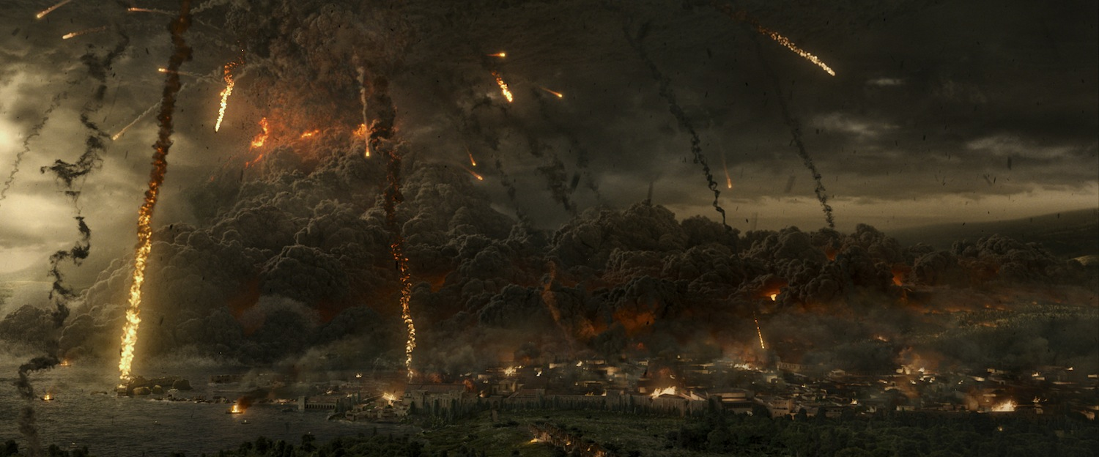
Watch the first video on geographypods. Complete the short response questions as set out in the boxes below.

What causes pyroclastic blasts?
How fast can these blasts travel?

What temperature can they reach?
What effect do they have on the human body?

Google Earth Tour of Vesuvius & Pompeii
In which country do you find Mount Vesuvius?

How far is the ancient city of Pompeii from the crater of Mount Vesuvius & which direction?

Up on the crater edge. Describe the crater carefully. What is it like inside?

Describe the view down from the crater edge towards the ancient city of Pompeii.

Now watch the 8-minute video on geographypods. Fill in the details below as your are watching the events unfold.
Sights | Smells
Sounds | Feelings

Now complete the ArcGIS tour of Vesuvius This was created by a school student about your age. Answer the questions below to build up a picture of this eruption.

Name two cities, other than Pompeii close to Vesuvius.

Which plates are involved in the creation and eruption of Mount Vesuvius?

When did the volcano last erupt?

How many people are thought to have died in the 79AD eruption?

How many people currently live very close to the volcano?

Look at the second map and the zones of destruction. What would happen to Naples if the volcano erupted again?

Body Investigator – The bodies found many hundreds of years later in Pompeii looked very different. Here are two famous pictures to show both. You need to use your detective skills to find out why they look so different.
Evidence Picture 1 | Evidence Picture 2
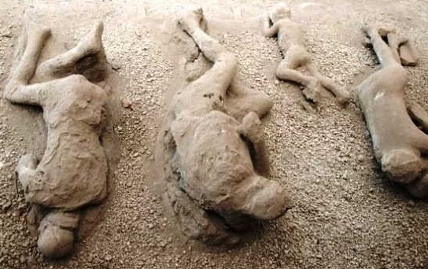 | 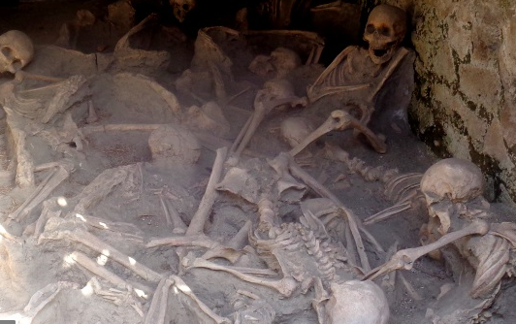
Explain how this happened? | Explain how this happened?
Where are these bodies? | Where are these bodies?

Other notes and thoughts about what you have seen so far.

